**Grove - Temperature and Humidity Sensor Pro**

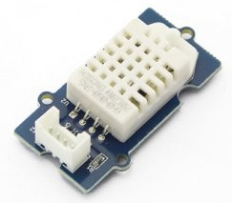

This is a powerful sister version of Grove-Temperature & humidity sensor. The detecting range of this sensor is -40degree C-80degree C. Its accuracy reaches up to 0.5degree C.

## **Specification**

| **Item** | **Min** | **Norm** | **Max** | **Unit** |
| --- | --- | --- | --- | --- |
| VCC | 3.3 | - | 6 | V |
| Measuring Current Supply | 1 | - | 1.5 | mA |
| Standby Current Supply | 40 | - | 50 | uA |
| Measuring range **(Humidity)** | 5% | - | 99% | RH |
| Measuring range **(Temperature)** | -40 | - | 80 | °C |
| Accuracy**(Humidity)** | - | - | ±2% | RH |
| Accuracy **(Temperature)** | - | - | ±0.5 | °C |
| Resolution **(Humidity)** | - | - | 0.1% | RH |
| Resolution **(Temperature)** | - | - | 0.1 | °C |
| Repeatability**(Humidity)** | - | - | ±0.3% | RH |
| Repeatability **(Temperature)** | - | - | ±0.2 | °C |
| Long-term Stability | - | - | ±0.5% | RH/year |
| Signal Collecting Period | - | 2 | - | S |
| Respond Time 1/e(63%) | 6 | - | 20 | S |

**REQUIREMENTS:-** Raspberry pi, Grove DHT sensor pro, Grove pi+

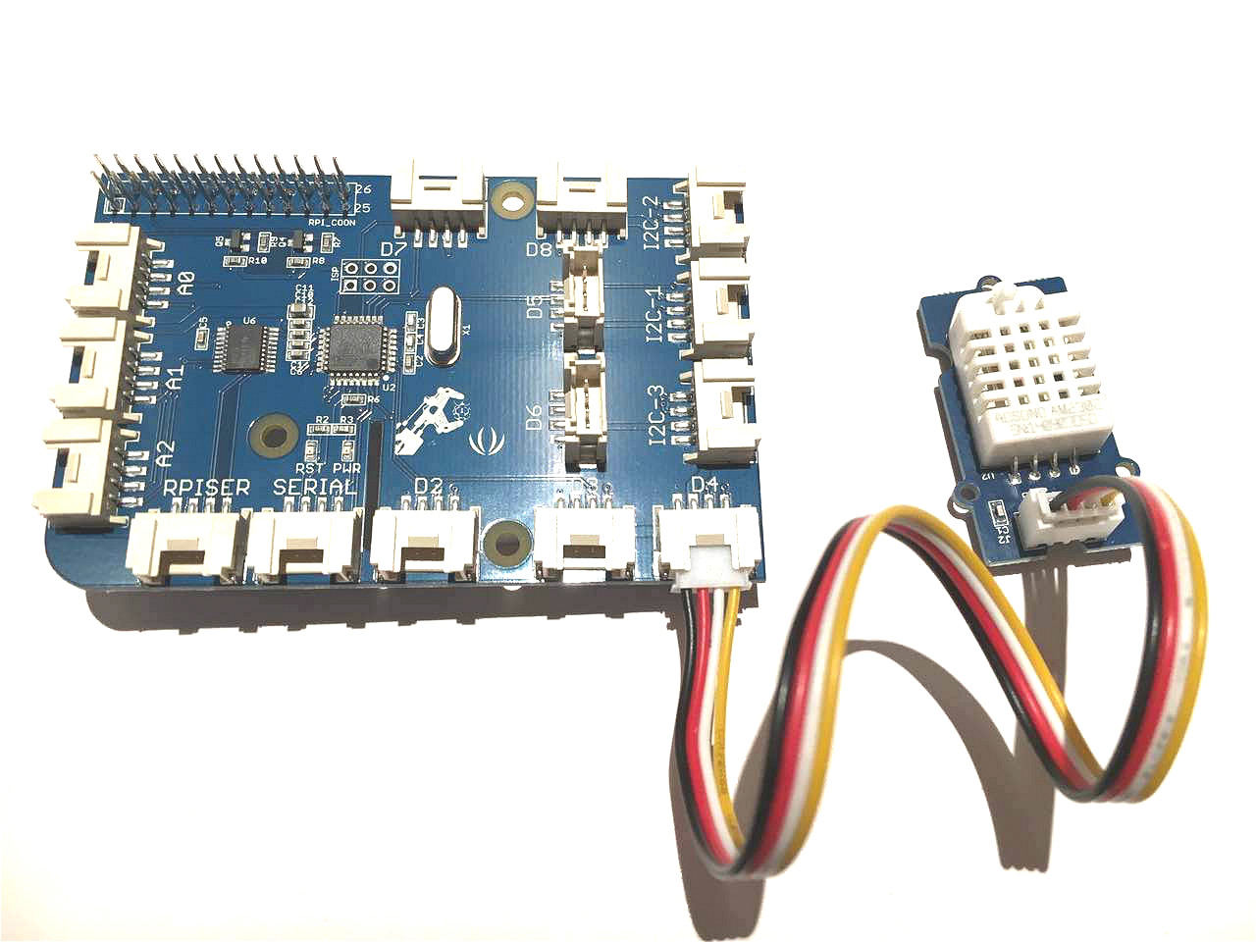

GrovePi+ is an add-on board that brings Grove sensors to Raspberry Pi.

Plug Grove DHT pro to the socket D4of grovepi+.

**Code:-**

* navigate to the demos’ directory:

cd yourpath/GrovePi/Software/Python/

* To see the code

nano grove_dht_pro.**py** # "Ctrl+x" **to** **exit** #

**import** grovepi

*# Connect the Grove Temperature & Humidity Sensor Pro to digital port D4*

*# SIG,NC,VCC,GND*

sensor = 4

**while** **True**:

**try**:

[temp,humidity] = grovepi.dht(sensor,1)

**print** "temp =", temp, " humidity =", humidity

**except** IOError:

**print** "Error"

* Run the demo.

sudo **python** grove_dht_pro.**py**

* Here is the Result.

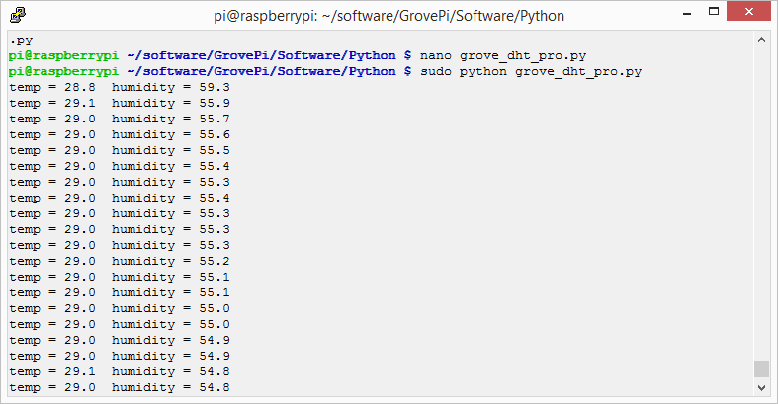

**Visit the link: -** http://wiki.seeed.cc/Grove_Temperature_and_Humidity_Sensor_Pro/